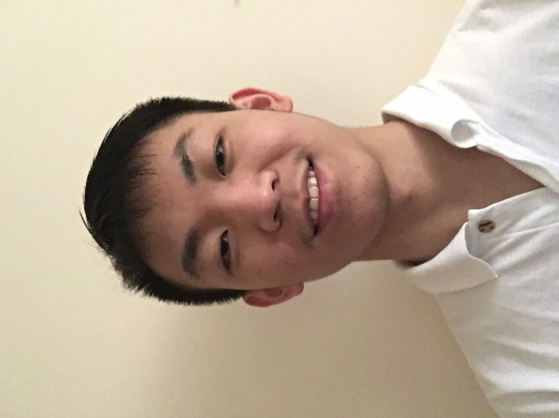

* (2015-2017): Bsc Computer Science in The University of Sheffield
  + 1st class
* (2014-2015): Sheffield International College (SIC)
  + Average score: 81%
* (2012-2014): Guigang Senior High School in Guangxi, China

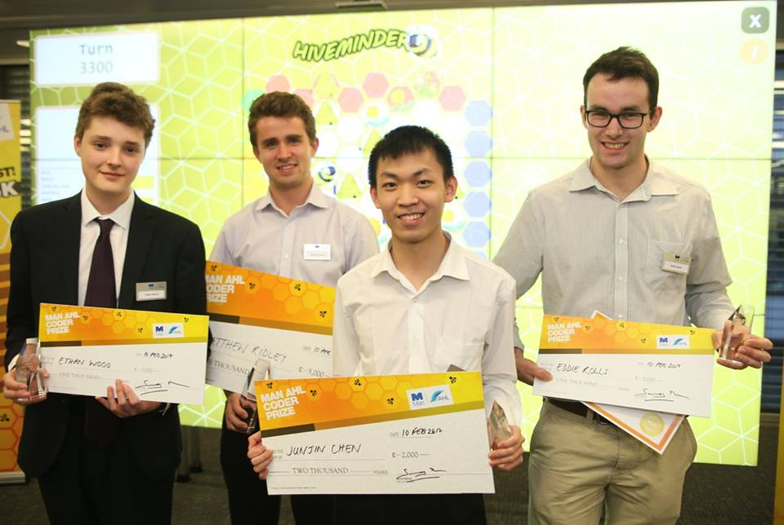

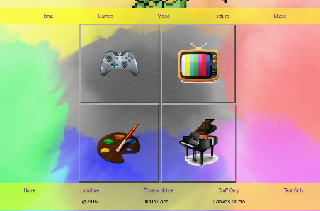

I chose Computer Science as my course because I love everything about computer, the power of fast computing, large information storage and etc. I learned a lot in this course, from the concept of programming (e.g. structure of OO language) to complex algorithms (e.g. A\* algorithm, Machine Learning, Deep Reinforcement Learning) to software management (e.g. Agile Method). I also have lots of achievements in this course work, such as making applications using Ruby (e.g. Liquid democracy system), analysing data using python (e.g. image-recognizing, forest-fire simulation) and so on. Outside my course, I also take part in coding challenges such 30hrs game jam and HiveMinder coding competition.

In HiveMinder competition I got the 2nd prize with £2000 reward (more details at: <https://www.ahl.com/coderprize>).

I am currently doing a research for applying deep reinforcement learning agent into a game called Starcraft2, with opening source from DeepMind. This project is challenging and it requires research skills like collecting relevant information and conducting experiments. By choosing this project, I can embed these skills to myself.

Contact info

Current address:

86 Weston Street, Sheffield

S3 7NQ

Email: [1099404025@qq.com](mailto:1099404025@qq.com)

Phone no: 07340241601

Personal info

Born in: 2nd March 1997

Gender: Male

Nationality: Chinese

Language

* Mandarin
* English
* Cantonese

Programming language

* Java
* Python
* Haskell
* C++
* Ruby
* JavaScript
* Html
* CSS

Interests

Computer games, Ping Pong, listening to Music, Painting.

Junjin Chen

* Social Innovation Lab (establish a virtual company with partners)
  + Ability to think independently, Time management, Teamwork.
* 24 hours inspiration volunteer (Sell tickets and raise money for people suffering from cancer)
  + Receptionist skill
* 30 hours gameJam (create a game with given theme in 30 hours)
  + Creativity, Game design skill,

Time-Management Skill

* Pair Programming competition
  + Communication skill
* Photoshop Lessons
  + Aesthetics
* 2nd Prize in HiveMinder coding competition
  + Ability to use knowledge from lectures